Eligible Employee Notification Letter

September 24, 2009

Dear UF Colleague:

I am writing to inform you that you may be eligible for a special Retirement Enhancement Program at the University of Florida. This program provides an attractive incentive for employees to consider if they elect to separate from the University of Florida on or before June 30, 2010. Enrollment in the program is voluntary and is available to employees who qualify based on the specific eligibility requirements outlined in the enclosed policy.

As an eligible employee, I encourage you to read the enclosed information carefully so you can determine if this program is a viable option for you. Please note there is a limited window of opportunity to take advantage of this program since the enrollment period for the program ends on Friday, January 8, 2010. In addition, we anticipate that this program will not be offered in subsequent years.

Enclosed is a copy of the program policy details and a frequently asked questions document that I hope will assist you with your decision. In addition, we will be offering information sessions regarding this program on the following dates:
10/1/09 2-4 p.m. Brain Institute LG101A (DeWeese Auditorium)
10/9/09 2-4 p.m. Human Resource Services Training Room 120
10/20/09 2-4 p.m. J. Wayne Reitz Union Room 287
If you elect to enroll in this program, please complete the enclosed enrollment and separation agreement forms and send them to Human Resource Services on or before 5:30 P.M Friday, January 8, 2010.
If you have questions about the Retirement Enhancement Program, including retirement options, please contact University Retirement at (352) 392-2477 or retirement@ufl.edu.

Sincerely,
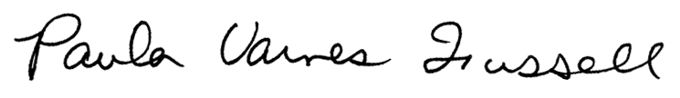

Paula Varnes Fussell
Vice President for Human Resource Services

Enclosures: Program Policy
Frequently Asked Questions
Enrollment Form
Separation Agreement Form
Exhibit A: Age Discrimination in Employment Act Disclosure

